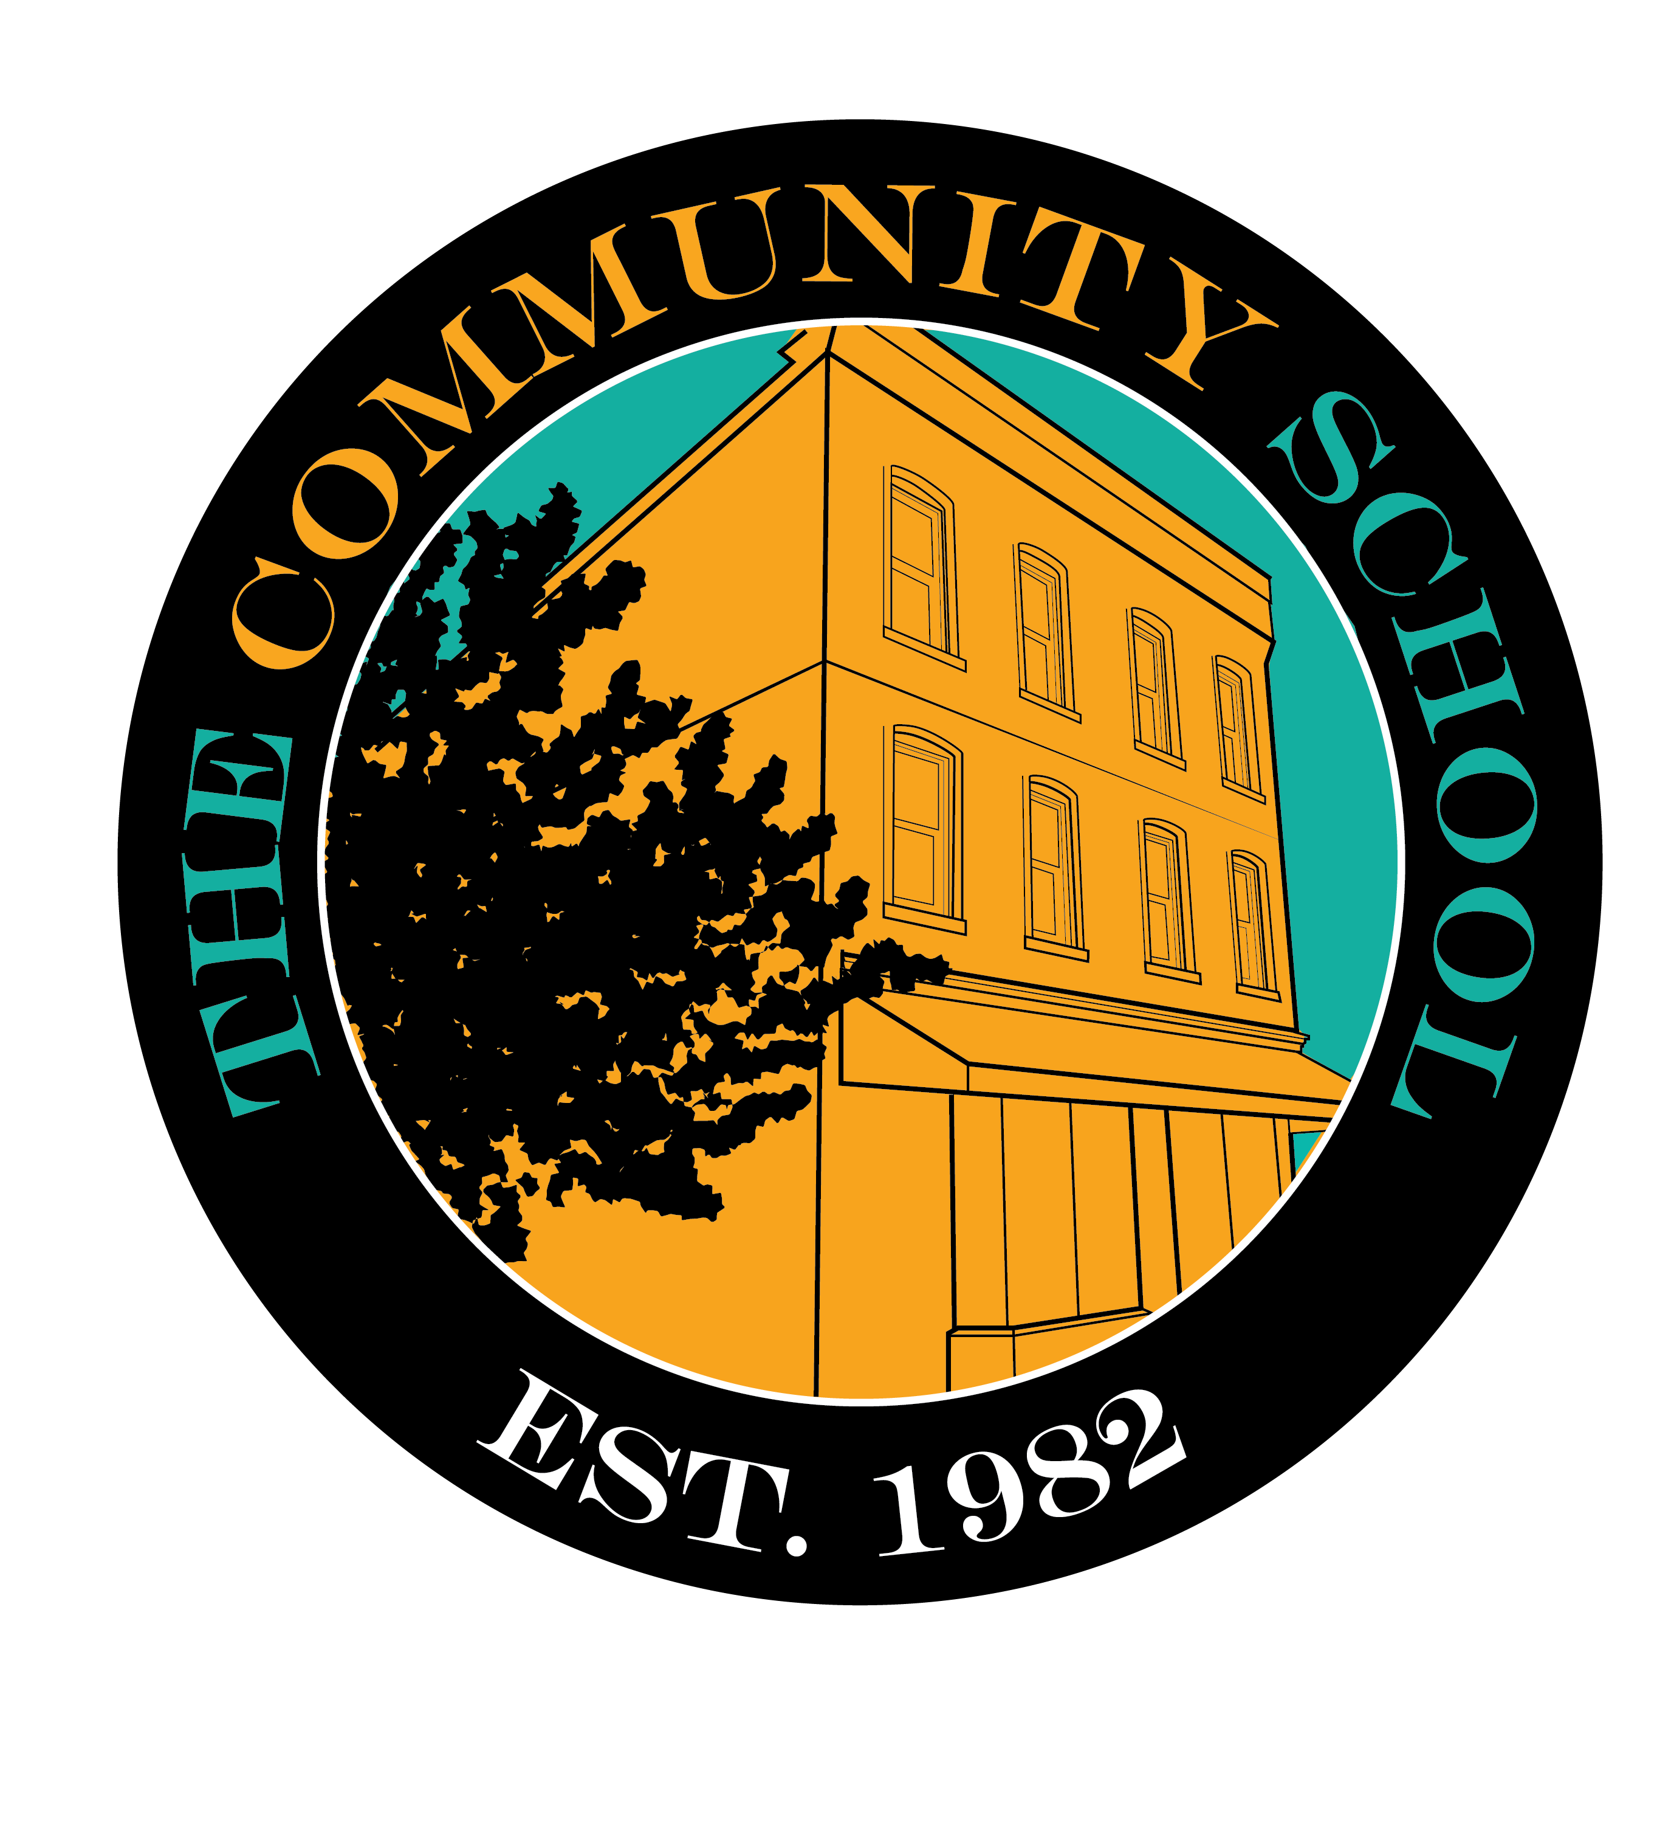
Student Handbook
2022/2023 Term
(rev. 01/10-23)

Table of Contents

Topic Page

Table of Contents 2

Mission Statement 3

Honor Code 4

Calendar 5

Schedule 6

5 Habits 7

Admissions 8

Student Status 9

Characteristics of a TCS student 10

Attendance 11

Tuition 11

Family Representative 12

Sponsors 12

Graduation Requirements 13

Courses 14

Grades 15

Enrichment/Extra Credit 15

Dual Enrollment 15

Independent Study 16

Self-Care 16

Health 17

Clean Up 18

Electronic Technology 18

Organization 19

Communication 19

General Courtesy 20

Concerns, Crticisms & Accountability 21

Confidentiality 21

Class Size & Teacher/Student Ratios/Teacher Qualifications 21

Commitment to Equity, Equality and Civil Rights 22

Staff, Board & Contact List 23-24

Thoughts About Education And Life 25

Our Mission Statement

The Community School,
an academic and mentoring high school,
based in the Remington Community,
is for young people committed
to advancing their education,
improving their lives and
bettering their community.
The School develops the skills, knowledge,
creativity, confidence, intellectual curiosity,
knowledge of self and worldview
of students
in a safe, supportive and comfortable,
yet rigorous, environment.

Honor Code

The Honor Code of the School is based on respect, trust and honesty.

I pledge to be honest in both words and actions. I will not lie, cheat or steal.

I seek an atmosphere of comfort and caring. I will conduct myself in a friendly, cooperative and responsible manner to contribute to this atmosphere.

I will tolerate, respect and appreciate individuals of different races, cultures, religions, genders, sexual orientations, abilities, and national origins and without regard to immigration status. I will be careful when talking, not cursing or using words that put down a person’s circumstances or background or speaking offensively about others, whether in or out of their presence.

I will settle conflicts in a positive manner and will resolve problems without fighting, either verbally or physically.

I will both offer help and accept help from my classmates, school staff and volunteers. I will not discourage others by my words or actions.

I will care for myself, classmates, school community, school staff and facility by working to build each up instead of being destructive.

I will not allow drug or alcohol use or possession either in school or in my personal life, and will not let these substances keep me from reaching my goals.

I will always strive to do my best and will use my effort to make the school the way I would like the world to be.

I will invest myself fully in the school, actively engage in all of my classes and participate in school activities in a thorough and positive manner.

I understand that I have chosen to be here and that I am responsible to not only follow the Honor Code but also to uphold it. I am responsible to deal with any breach of the Honor Code and to promptly bring any serious violation to the attention of the school.

The Community School
2022/2023 Calendar

The school year will begin on Wednesday, September 7th and will end on Friday, May 26th. Classes are held Monday through Friday except on the following designated days. Inclement weather make-up days will be during the week of May 9th .

Orientation Meeting September 6th
1st day of Class Wednesday, September 7th
Sponsor Meeting Wednesday, September 28th
Thanksgiving Holiday November 24th – 25th
End of 1st Trimester (59 days) Wednesday, November 30th
Sponsor Meeting Wednesday, December 7th
Winter Break Dec 23rd – January 1st
End of 2nd Trimester (58 days) Tuesday, February 28th
Sponsor Meeting Wednesday, March 8th
Spring Break April 1st – April 9^{h}
Sponsor Meeting Wednesday, May 24th
End of 3rd Trimester (58 days) Friday, May 26th (Last Day of Class)
End of Year Ceremony ………………………... Sunday, June 4th
Make-Up Days May 29th – June 2nd

Total Days of Instruction: 175

Snow Policy: Snow delays and closings will be advertised on the news media,
our website and through our text notification service.

(revised: 09-04-22)
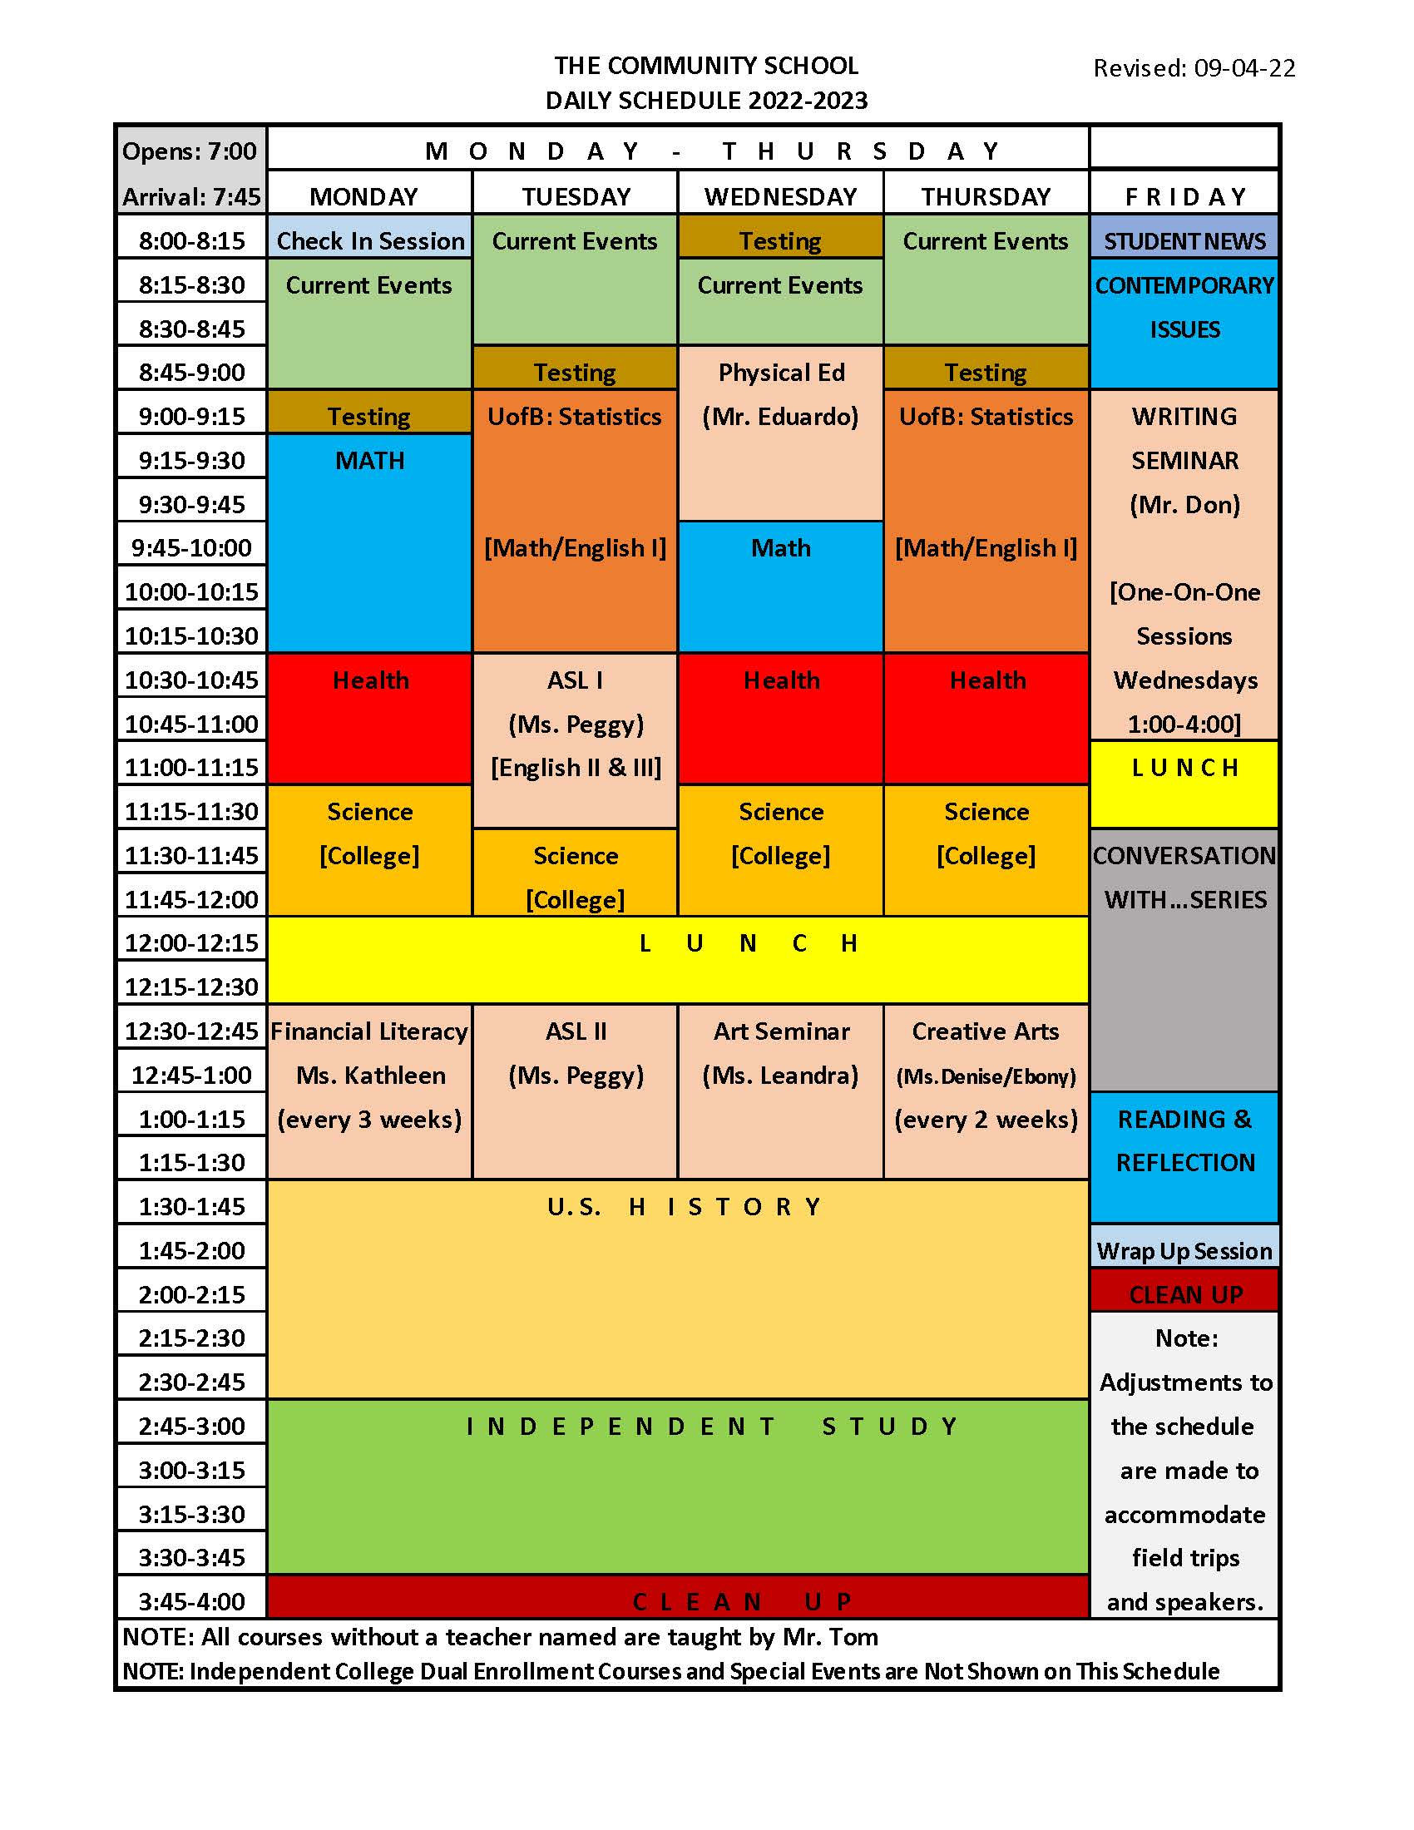

The 5 Habits
Of A Successful Student

Show up every day,
on time,
prepared to learn,
with a positive attitude,
and all of our work.

Admissions Process
The Community School is for students who are prepared to fully engage in our school and embrace both personal and academic growth, follow the Honor Code, and commit to the 5 Habits of a Successful Student.
The Community School accepts applications from all students, regardless of race, religion, ethnicity, sexual orientation, gender identity, national origin, immigration status or color, aged 13 through 16, who have completed 8th grade and are committed and self-motivated to advance their education, earn a high school diploma and prepare for college and a career.

Application/Registration:
1. To begin the process, the prospective student must fill out a pre-application on our website (www.tcshighschool.org).
2. The School will then be in contact to schedule a shadow day.
3. After attending a shadow day, a handwritten application must be completed by the student and turned into the School by dropping it off or mailing it to: The Community School, 337 West 30th Street, Baltimore MD 21211-2810.
4. After an initial review, the applicant will be notified if his/her application is being considered. If so, a one-on-one interview will be scheduled with the student.
5. Following the interview, the applicant will be notified if accepted. An appointment will then be scheduled with the student and his/her parent or guardian for a registration meeting.
6. The registration process then begins with the applicant and parents/guardians completing all applicable admission forms, including a tuition agreement, and submitting a nonrefundable $50 registration fee and a one-time book deposit of $100.
7. Once accepted into the School, the student is required to take a series of placement tests in math and English.
8. In order to complete the initial registration process, transfer papers, including transcripts, vaccine records and a copy of the student’s birth certificate, as well as the $50 registration fee, must be received by the School.
9. A student is fully registered when all paperwork, testing and meetings are completed and the book deposit has been received in the timeframe that has been established.

Student Status

It is important to always remember that it is a privilege and an honor to be a student in The Community School. The school only accepts and works with a small group of dedicated students who are given individual care and attention as well as daily opportunities for personal and academic growth. In return, the students are expected to always be and give their best. To remain in the school, a student must consistently display strong character, solid habits and full engagement in the program.

Permanent Status

A student attains permanent status when he/she is a fully participating member of the student body and consistently demonstrates the character, engagement, and habits required.

Conditional Status N

New students in the school begin on a conditional status. Each new student is given the opportunity to display the character, engagement and habits of young people in The Community School. A student’s status is changed from conditional to permanent once he/she demonstrates the consistent traits necessary to be a part of TCS. This is typically determined within the first 20 class days. If a student does not meet the standards required and has not demonstrated the drive or ability to meet those standards, he/she may no longer be allowed to continue at TCS.

Conditional Status P

A permanent student may be placed on conditional status if he/she no longer meets the standards of TCS in character, habits or engagement. This is for a period of no less than two weeks and lasts until there is a sustained improvement in the student. A student on this conditional status may lose his/her tuition subsidy from The Community School.

Suspended

A suspension is used very rarely and is only indicated during the decision-making process to determine whether a student should remain in the school after a serious transgression. During a suspension, the student is not allowed at the school.

Expelled

A student may be expelled for any serious breach of the Honor Code, for failure to come up to standard while on conditional status or for any matter determined serious by the Head of School.

Process/Decision Making

A student’s status is determined at the sole discretion of the Head of School. When a student’s status is changed, he/she is informed in writing of the reason or reasons that precipitated the change, and if not an expulsion, the corrective measures expected. The decision to expel may be appealed to the Board of Trustees up to 5 days after the student and family have been informed.

Characteristics of a TCS Student

There are certain characteristics that are common to all students of The Community School. TCS students are kind, polite, confident, and communicate well and directly.

In order for a new student’s status to change from conditional to permanent, the student must exhibit all of the following:

Character

… abide by and uphold each and every provision of The Honor Code

… respect the structure and follow the rules of the School without prompting as evidenced by showing up to classes on time, performing all chores and cleaning responsibilities, and consistently being prepared for class and seminars

… evidence maturity through appropriate behavior and helpfulness

Engagement

… participate fully in class, seminars and activities

… develop positive relationships with teachers, staff and classmates

… volunteer and help around the school

Habits

… show up at school every day and on time

… get sufficient sleep to come to school fully rested and prepared to learn

… complete all work assigned – neatly and completely - and turn work in on time

… study alone and with other students

In addition, to become and remain a Permanent Student

… tuition must be up-to-date and consistently paid on time

… a student must have at least two actively engaged sponsors who are fulfilling each of their responsibilities

Attendance

Good attendance assures that the student will not fall behind in his/her studies and will enable a student to develop good habits for life.

1) For an absence to be considered excused:
a) It must be unavoidable; b) The student must call (not text) the School as early as possible, but no later than 7:45 a.m., and talk to a member of the staff; c) Upon return to School, the student must bring in missed classwork and assigned work.

2) Students must arrive by 7:45 a.m. and be in their seats, ready for class by 7:50 a.m. If a student is going to be late, he/she must call the School before 7:45 a.m. and talk to a staff member - texting is only acceptable if the student may be just a few minutes late.

3) Medical appointments should be scheduled when school is not in session or, if necessary, during independent study. If it is unavoidable and conflicts with the class schedule, the student should miss as little of the school day as possible. It is important to notify the school as soon as an appointment is made that will affect the student’s participation in the class day.

Tuition

The cost of educating a student at TCS is approximately $12,000/year. The maximum tuition to attend the school for the 2022/2023 term is set at $4,800 or 40% of this total. The Trustees have developed a Tuition Assistance Program, providing a limited number of subsidies up to $3,800 on a sliding scale based on family income, household size and volunteerism.

1) A signed tuition contract must be in place before a student is fully registered at TCS. Payments may be by cash, check or money order on a weekly, monthly, trimester or annual basis. Tuition can also be paid by credit or debit card through the tuition portal on the website.

2) A family may apply for tuition assistance from TCS with a completed Tuition Assistance Program application. A packet will be provided upon request explaining this program, eligibility criteria and the sliding fee scale.

3) If tuition is not paid by noon on the first day of the period owed, a late fee of $5.00 will be assessed for each week that it is overdue.

4) If tuition payments are behind, the student will not be allowed to take books home. If tuition is more than 2 weeks in arears and arrangements have not been made with the School, the student may no longer be allowed into class until the tuition is brought up-to-date and may be dropped from the roll.

5) If a student leaves school with tuition owed, tuition will be prorated and the amount owed will be deducted from the book deposit before the deposit, if any, is refunded. Refunds are mailed within 7 days after all books have been returned in good condition.

Family Representative

The Family Representative provides a link between the family and the School to facilitate communication, allow for coordination and reduce conflict.

1) Each student is required to have a parent or guardian as a family representative.

2) The family representative must agree to:
a) Encourage the student and promote positive habits consistent with participation in the School
b) Communicate with the School in a positive manner with any concerns about the well-being of his/her child and be available to meet, if necessary

3) Each family is expected, on a monthly basis, to either prepare a lunch for the students or volunteer at the school.

8) If a family member does not fulfill his/her obligations or should serious disagreements arise between Head of School and the Family Representative, the School could require the appointment of a new Family Representative.

Sponsors

Sponsors give individual support and encouragement to the student; help resolve any issues or conflicts that may arise concerning the student; and provide support for the School and its activities.

1) Each student is required to have at least 2 active sponsors. A sponsor can be a family member or other important adult in his/her life.

2) If a student has difficulty finding sponsors, the School will assist the student in finding them. Subject to the approval of the student, the School may also appoint sponsors from outside the student’s family to enhance the student’s support team.

3) Each sponsor must fill out a sponsorship form and attend an orientation session at the school.

4) Each sponsor must communicate with the student at least once a week about his/her
progress or problems in the School, including study, attendance and homework habits.

5) Each sponsor must maintain positive relations with the staff and contact the School at least once every few weeks by email, phone or in person to discuss the student’s progress.

6) Sponsors are required to attend up to 5 sponsor meetings each year and are encouraged to attend all events during the school term.

7) Sponsors must support the student and the School in a significant way, including by volunteering their time to serve on or otherwise support at least one of the committees established by the sponsors.

8) If a sponsor does not fulfill his/her obligations, the sponsor may need to be replaced.
Credit Requirements for Graduation
The Community School’s requirements for graduation align with the Maryland State Board of Education Title 13A.09.09.09 which requires a minimal of twenty-one credits, including four in English-language arts, two in social studies with at least one credit in U.S. History, and six in science and mathematics (at least two credits in each).

The Community School Unit of Credit
A student in The Community School is expected to earn at least 25 credits to graduate which includes a minimum of 23 credits as prescribed below:
English Language Arts | 3 Credits | Health - Life Skills | 1 Credit
Mathematics | 3 Credits | ELA: Writing | 2 Credits
Science | 3 Credits | ELA: Literature | 1 Credit
Social Studies | 3 Credits | Physical Education | 1 Credit
Health Education | 1 Credit | Fine Arts | 1 Credit
Contemporary Issues | 3 Credits | Social Responsibility | 1 Credit

Criterion for awarding of credit
Credits are earned through successful completion of the academic course [a minimal course grade of 70% based on assessment, attendance, and work completed], meeting established standards and outcomes, and/or other assessments as determined by the School.

Criterion for accepting transfer credits
Transfer credits from a certified secondary school are accepted for courses that align with those taught at The Community School. The student’s performance in the course must meet or exceed the School’s standards, including a minimal grade of 70%, and the demonstrated knowledge and skills in the content area. Transfer credits that don’t meet this standard will be reviewed on a case-by-case basis.

Community Service
To earn the Social Responsibility credit, each student is required to complete a coordinator role for a minimal of 6 trimesters in one or more areas. In addition, the student must complete a minimal of 10 hours of approved volunteer community service for each year he/she attends the School.

The Community School retains the right to make some adjustments to credit requirements for graduation in situations where a student’s accomplishments in a particular area warrant it. In all cases, the requirements of the Maryland State Department of Education for Non-Public Schools will be met.
Courses Offered and Credit Breakdown

ENGLISH LANGUAGE ARTS Health (1 credit)
English Language Arts I, II & III (1 credit each)
Basic Writing (.5 credit) Contemporary Issues – 4 levels (1 credit each)
College Writing (.5 credit)
Creative Writing – 4 levels (.5 credit each) Health: Life Skills (1 credit)
Literature – 4 levels (.5 credit each)
MATHEMATICS College & Career (1 credit)
Basic Math Skills (1 credit)
Integrated Math I & II (1 credit each) Physical Education – 4 levels (.5 credit each)
Reviewing Integrated Math (.5 credit)
Financial Literacy (.5 credit) Technology Education (1 credit)
SCIENCE
Physical Science (1 credit) Social Responsibility (1 credit)
Basic Biology (.5 credit)
Basic Chemistry (.5 credit) ARTS
Advanced Biology (1 credit) Art Appreciation (.5 credit)
Earth Science (1 credit) Theatre Arts (.5 credit)
SOCIAL STUDIES Visual Arts (.5 credit)
World Geography (1 credit) Film Appreciation (.5 credit)
U.S. History (1 credit) LANGUAGE
U.S. Government (1 credit) American Sign Language – 2 levels (.5 credit each)
World History (1 credit)

Note: The Community School has a partnership with both the University of Baltimore and the Community College of Baltimore County for dual enrollment. Students have the opportunity, and may be required, to take college level courses which will count as both high school and college credits in accordance with Maryland State Department of Education guidelines.

Grades

Grades enable the student and the teacher to determine how well the student is learning in each subject and to take corrective measures if necessary.

1) Each student should strive to achieve a grade of at least 80% in each class. However, the minimal grade to earn a credit in The Community School is 70%. A student is considered to be “in crisis” in a subject if he/she has an average below 70%.

2) The School operates on a system of 3 trimesters, with each averaging 58 class days. Detailed report cards are given at the end of each trimester to allow students, their parents or guardians and sponsors to review their progress and to address and adjust any habits that may need to be improved.

3) In most courses, students are given a number percent grade with 50% counted from test grades, 35% from quiz grades and 15% for Independent Study (homework) completion.

4) Students, sponsors, and family representatives have constant access to grade, attendance and homework records through the Thinkwave program and internet access.

Enrichment & Extra Credit

Enrichment assists the student in not only improving his/her understanding of the subject but also improving the student’s grades in each subject area.

1) Any student may request enrichment but it may be required for any student who has an average below 70% in a course.

2) Enrichment may include additional materials, individual tutoring, assistance with reading when testing, or extra credit assignments. This assistance may be written into an agreement.

3) Students may request extra credit in most subjects to enrich their understanding of the course material.

Dual Enrollment

In order to enhance the student’s education, TCS has a partnership with the University of Baltimore and the Community College of Baltimore County allowing students to enroll early in college and begin taking courses through dual enrollment.

1) Any student with a GPA of 2.5 or higher may be eligible for dual enrollment.

2) Students may be required to take college courses as part of their studies at TCS.

3) College classes may be in person, remote or online. Attendance and homework may be both during the school day and outside the normal schedule.

Independent Study

Independent study (homework) enables students to advance at a faster pace academically and encourages independent interaction with the material.

1) Students are required to attend study sessions immediately following the class day. All work is assigned on Google Classroom with a time and date when it is due. It is the student’s responsibility to check Google Classroom for assignments.

2) Independent study sessions are staffed. If a student needs help with assigned work, it is his/her responsibility to ask for assistance from the staff.

3) Independent Study work counts for 15% of the course grade. Credit is only given if it is completely done and turned in on time.

4) If assigned work is not brought in for a given day, the student will need to make it up that day, either before school, during breaks or after school. Completed homework in a subject area is required in order for the student to be allowed into that class.

5) If a student is absent, it is his/her responsibility to get the classwork and assignments and bring them to school the next day. The work can be picked up during the independent study session.

Self-Care

Good self-care promotes an individual’s good health and recognizes that he/she is part of the school community.

1) A student is expected to practice good hygiene on a daily basis, including bathing and washing the body, brushing teeth, using deodorant, and making sure his/her clothes are clean and odor free. Care should be taken not to use excessive perfumes, body washes or other similar substances.

2) Students are expected to come to school mentally alert. They must be sure to have a good night’s rest by allowing sufficient time for sleep - usually 8 to 9 hours.

3) Students must not use or possess drugs or alcohol or be involved in the drug trade, whether during or outside of school.

4) Students must dress decently and appropriately for a learning environment. Clothes should be clean and free of odor. Sandals, sleepwear or clothing that promotes drugs, violence, racism or hatred is not acceptable. Students must wear well-fitting tennis shoes on gym day.

5) If a student has difficulty obtaining hygiene products or clean clothes, it is important for the student to let the School know so support can be provided.

Health

TCS takes the health of its students very seriously. This includes frank and open discussion with accurate information based on science. Students are encouraged to take care of their health, including regular physical, vision and hearing checkups.

1) The family representative must complete an emergency medical form which includes emergency contact information, medical providers, medical insurance and student health conditions or concerns. The person designated on the emergency medical form by the parent/guardian will be notified promptly should there be any significant medical incident.

2) The School must be notified in writing of any chronic or acute health problems involving ongoing treatment. The notification must include a description of the health problem, treatment, medications, and needs and expectations of the School related to the health issue. The School reserves the right to determine that it is not capable of meeting the health need of the student.

3) If a student is taking medication or must use an inhaler, insulin injection, auto-injectable epinephrine or other such medical device, provisions must be made with the School for its use and proper storage. The prescribing doctor must submit to the School a written statement that the student has received proper training and procedures for use and follow-up emergency procedures.

4) Students have access to over-the-counter pain-relieving medications - acetaminophen and ibuprofen - as well as Tums for indigestion. Students can take these unsupervised if the parent /guardian signs a form permitting this and releasing the School from any liability.

5) Birth control and STD prevention are encouraged for students, male or female, who are sexually active. Students and their parents/guardians are encouraged to share their values and beliefs and have an open and thorough discussion on this topic with their student.

6) In order to promote and ensure a positive atmosphere in the school, romantic relationships between students are strongly discouraged. Problems between students could result in a dismissal from School.

7) The school follows all local, state and federal requirements regarding safety during COVID-19. Our procedures are listed in a separate document of Covid protocols which is updated as conditions change.

8) If a student does not have medical insurance or has difficulty obtaining medical care, the School will assist with referral to available resources.

Clean Up

In order for the School to operate in a clean environment, keep costs down and develop student responsibility, each student is required to assist in the maintenance of the School.

1) Each student will be assigned an area of the School to thoroughly clean and maintain on a daily rotating basis. If a student is absent, his/her duties will be exchanged with the student who has the same assignment the next day.

2) Clean-up is performed at the end of every class day. Students are expected to co-operate with those who have clean up duties and to maintain an area that has already been cleaned.

Electronic Technology

The School encourages familiarity with the use of computers and other electronic devices and in proper protocols in their use.

1) Computers are for school use only. A laptop will be assigned to each student to use in school. The student must take good care of it and use it at the teacher’s direction for research, Google Classroom and the McGraw-Hill resources website. Computers cannot be used to go on social networking, gaming, YouTube, file sharing, or any other sites unrelated to the curriculum.

2) Cell phones must be silenced, including not vibrating, and turned in no later than 7:50 each morning. Phones may be used during the 2 designated break periods but must be turned in 2 minutes prior to the end of each break. Failure to turn in his/her phone will be considered a violation of the Honor Code, and the student will lose phone privileges. In addition, phone privileges will be suspended if independent study work is not complete.

3) Unless specified in the course, calculators cannot be used for either class work or independent study.

4) For the sole purpose of enabling a student to do school work at home, the School will offer to loan a Chromebook, subject to the student and his/her parent signing an Equipment Loan Agreement that provides for the laptop being taken care of, kept safe and in its original condition, not lent to anyone else, and returned to the School at any time requested. If damaged, lost or stolen, the student and his/her parent/guardian will be obligated to pay $200.00 as a replacement fee. Only students on permanent status are eligible to utilize this program.

Organization

The School operates within an organized structure and teaches these methods to the students so that that it can operate efficiently and the students can concentrate on their academic development.

1) Students must label all of their work in the School with their names, dates and identifying information.

2) Tabs need to be moved to current assignment in all notebooks, except math.

3) Students are not to scribble, draw or make stray marks in or on their school texts, notebooks, folders, tests or dittos.

4) Students are responsible to maintain their work areas, lockers and school materials in a neat and orderly manner.

Communication

Good communication and healthy relationships are important ingredients of success, both for the individual student and the School.

1) Regular communication between students and teachers, directly and through journals, is required and helpful.

2) If a student, parent/guardian or sponsor has a problem or concern, it should be discussed before it grows into an even larger problem.

3) Texting is not an acceptable way to have meaningful communication with the School, either by a student, his/her parent guardian or sponsor. It is okay to use a text to arrange a meeting or for a quick check in.

4) Each student is assigned a unique TCS email account. Students need to check this account daily for assignments, notices and communication.

5) The School utilizes the Remind texting and email service to send out group communications for reminders, notices and emergencies. All students, family representatives and sponsors are required to sign up for this service.

6) All communications from the School to student, family and sponsors must be responded to in a timely manner. This includes just acknowledging receipt of each communication.

7) Students, parents/guardians, and sponsors are encouraged to check our website weekly and to watch TCS Student News to stay current on what is happening around the school.

General Courtesy & Safety

A safe and comfortable atmosphere is essential to the learning process and to create a pleasant work environment.

1) Students are expected to exhibit good manners by greeting staff and each other when arriving and by shaking hands and saying goodbye when leaving. Requests should be preceded by the word “please,” and “thank you” should always be expressed to show appreciation.

2) Students are to greet guests in the building, make them feel welcome and help them when needed.

3) Students are expected to fully participate in class in a way that adds to the understanding of all students. A student should be attentive, including with positive body language, and not distract others. It is important to neither dominate the conversation nor interrupt others when someone is talking.

4) Students may not take photos or record videos in school or during school events without the expressed permission of the teacher.

5) Students are responsible for their social media posts and must make sure that they do not violate the Honor Code of the School or violate another person’s privacy.

6) Drinks are allowed in class as long as they are in leak and condensation-proof containers and their use is not disruptive to the learning process. Students cannot leave the class for drinks.

7) Students need to clean up after themselves.

8) Students are not to leave the school premises during the school day unless accompanied by staff.

9) The Community School is a smoke free environment. Neither staff, students nor visitors are to smoke in or around the building.

10) Students are to be considerate with food. It is important to share and not take more than your fair portion. Food should never be wasted. Food is not allowed during class. No gum is allowed in school.

11) If a student has head lice or bed bugs, the School must be immediately informed by both the family and the student. The School has policies and procedures to help the involved student and the class as a whole.

12) For the safety of the students and school, the school utilizes security cameras with recorded footage in all common areas inside and outside the school with the exception of the bathrooms.

12) If there is ever an emergency at the school building that requires an evacuation, the students are to immediately gather at The GreenMount School at 501 West 30th Street (410-235-6295) where staff will coordinate further action and families will be notified.

Concerns, Criticism, & Accountability

The School strives to operate with integrity and honesty, consistent with the Mission and the Honor Code. It is important that all concerns, criticisms and complaints be dealt with positively, directly and promptly.

1) If a student, parent/guardian, sponsor, or any member of the school community has a concern or complaint about the staff, program, or operation, the issue should be brought directly to the Head of School.

2) If a person is not satisfied with the resolution of the problem, an email should be sent to the Board of Trustees [trustees@tcshighschool.org] or a letter sent to the Board [Trustees, 337 West 30th Street, Baltimore MD 21211]. All Board members will be sent a copy. It will then be brought up at the next scheduled Board of Trustees’ meeting or sooner if deemed an emergency, after which the Board will respond directly, in a timely manner.

Confidentiality

The right to privacy is respected. Students, families and those whom they authorize in writing will have access to the student’s records. Any staff that has access to a student’s records or confidential information must sign a statement agreeing to The Community School’s confidentiality policy.

Conversations between the Head of School and students are confidential and will not be revealed to Family Representatives and Sponsors unless the student consents to it or it is a situation that the Head of School determines places the student or others in danger.

Class Size and Student to Teacher Ratio

The School believes in manageable class sizes that are conducive to creating a positive learning environment and adequate interaction between the student and teacher. Our policy regarding class size and student to teacher ratios reflects this belief.

The student:teacher ratio for instruction in all credit courses in The Community School shall not exceed an average of 15:1.

Teacher Qualifications

All teachers in The Community School responsible for oversight of curriculum and instruction shall at minimum meet the standards for teachers in nonpublic secondary schools established by the Maryland State Department of Education.

Commitment to Equity, Equality and Civil Rights

The Community School is fully committed to Equity, Equality and Civil Rights in all areas of our operation from program to administration, student recruitment to staffing.

Our policies include a commitment to the following:

“It is the policy of the State of Maryland that all public and publicly funded schools and school programs operate in compliance with:
(1) Title VI of the federal Civil Rights Act of 1964; and
(2) Title 26, Subtitle 7 of the Education Article of the Maryland Code, which states that public and publicly funded schools and programs may not:
i. Discriminate against a current student, a prospective student, or the parent or guardian of a current or prospective student on the basis of race, ethnicity, color, religion, sex, age, national origin, marital status, sexual orientation, gender identity, or disability;
ii. Refuse enrollment of a prospective student, expel a current student, or withhold privileges from a current student, a prospective student, or the parent or guardian of a current or prospective student because of an individual’s race, ethnicity, color, religion, sex, age, national origin, marital status, sexual orientation, gender identity, or disability; or
iii. Discipline, invoke a penalty against, or take any other retaliatory action against a student or parent or guardian of a student who files a complaint alleging that the program or school discriminated against the student, regardless of the outcome of the complaint.”

Staff List

Program Staff:
Head of School/Core Teacher Tom Culotta TomCulotta@tcshighschool.org

Seminars
Creative Writing Don Riesett
Physical Education Eduardo Viana
American Sign Language Peggy Lashbrook
Art Education Leandra Laird
Theatre Arts Denise Gantt & Ebony Evans from The Lyric
Financial Literacy Kathleen Gower & Staff from Berman McAleer

Administrative Staff:
Office Manager Leah Culotta LeahCulotta@tcshighschool.org
Resource Developer Peggy Lashbrook PeggyLashbrook@tcshighschool.org

Note: The Office Manager handles all of the school’s finances including tuition, registration fees and book deposits. Questions about any of these issues should be directed to Ms. Leah.

A complete list of current staff is available on our website.

Contact List

The Community School

Location 2939-41 Huntingdon Avenue
corner of 30th & Huntingdon
Mailing Address 337 West 30th Street
Baltimore MD 21211
Phone 410-467-4920
Email Office@tcshighschool.org
Website www.tcshighschool.org
Gym Location The GreenMount School
NOTE: This is also the emergency 501 West 30th Street
pickup location if ever needed Baltimore MD 21211
410-235-6295

Board of Trustees

President Tom Culotta
Cell Phone 410-804-4849
Only call the cell after you have not been able to reach
Tom on the school phone. Do not call after 7PM
unless it is urgent.
E-mail TomCulotta@tcshighschool.org

Chairperson W. David Bayer
Cell Phone 443-690-4560
Email DaveBayer@tcshighschool.org
Mailing Address 2937 Huntingdon Avenue
Baltimore MD 21211

Secretary Janiah Tillary
Treasurer Justin Switzer
At-Large Trustees Ed Gavin
Fleesie Hubbard
Stacy Laumann
Jeanette Norris

Thoughts About Education And Life

“I have learned that success is to be measured not so much by the position that one has reached in life as by the obstacles which he has overcome while trying to succeed.” Booker T. Washington
“Education is the great engine of personal development. It is through education that the daughter of a peasant can become a doctor, that the son of a mine worker can become the head of the mine, that a child of farm workers can become the president of a great nation. It is what we make out of what we have, not what we are given, that separates one person from another.” Nelson Mandela

“What the educator does in teaching is to make it possible for the students to become themselves.” Paulo Freire
“The older I grow, the more I am convinced that there is no education which one can get from books and costly apparatus that is equal to that which can be gotten from contact with great men and women.” Booker T. Washington
“Education is not the filling of a pail, but the lighting of a fire.” W.B. Yeats

“Whoever teaches learns in the act of teaching, and whoever learns teaches in the act of learning.” Paulo Freire
“Educating the mind without educating the heart is no education at all.” Aristotle
“I have begun everything with the idea that I could succeed, and I have never had much patience with the multitudes of people who are always ready to explain why one cannot succeed.” Booker. T Washington

“Everyone you will ever meet knows something you don’t.” Bill Nye

“You cannot dream of becoming something you do not know about. You have to learn to dream big. Education exposes you to what the world has to offer, to the possibilities open to you.”—Sonia Sotomayor

“Education without values, as useful as it is, seems rather to make man a more clever devil.” C.S. Lewis“
“Education is for improving the lives of others and for leaving your community and world better than you found it.” Marian Wright Edelman
“Strong minds discuss ideas, average minds discuss events, weak minds discuss people.” Socrates
“Learning is not the product of teaching. Learning is the product of the activity of learners.” John Holt

"We have a powerful potential in our youth, and we must have the courage to change old ideas and practices so that we may direct their power toward good ends." Mary McLeod Bethune.
“Every child deserves a champion – an adult who will never give up on them, who understands the power of connection and insists that they become the best that they can possibly be.” Rita Pierson
“There is nothing in a caterpillar that tells you it’s going to be a butterfly.” Buckminster Fuller

